Large-Eddy Simulation of a Rotating Cylinder at Subcritical Reynolds Numbers: Preliminary Results
Katie Cooper-Gray, John W. Kurelek, and Barbara L. da Silva
Department of Mechanical Engineering, Queen’s University, Kingston, Ontario, CANADA

Motivated by reducing maritime emissions, preliminary results will be presented on the flow development of a rotating cylinder as a first step towards the analysis of rotor sail performance. Three-dimensional large-eddy simulations (LES) of an infinite rotating and non-rotating cylinder were conducted at Reynolds numbers Re_{D} = 3,900 and 10,000 to verify the performance of discretization schemes, sub-grid scale (SGS) models, grid resolution, and domain size. The goal of these tests was to validate results against available literature to establish an accurate and reliable foundation for the development of the finite rotating cylinder model at Re_{D} = 10,000. This finite cylinder model will be used to study rotor sail tip vortex generation and wake dynamics for different velocity ratios, aspect ratios, and endplate sizes and to ultimately understand lift generation mechanisms for rotor sail design optimization.
The preliminary results presented at the Thousand Islands Fluid Dynamics Meeting will include coefficient of pressure distributions along the cylinder surface, wake profiles, and time-averaged bulk flow quantities such as lift, drag, and vortex recirculation lengths for the infinite cylinder validation tests and for the finite cylinder tests at velocity ratios between one and five. Future work will test different aspect ratios and endplate sizes to determine the effect on lift generation. Figure 1 shows the pressure coefficient along the infinite cylinder surface for various velocity ratios and Re_{D} = 10,000. Presented results are in good agreement with those presented in literature, validating the simulation setup.
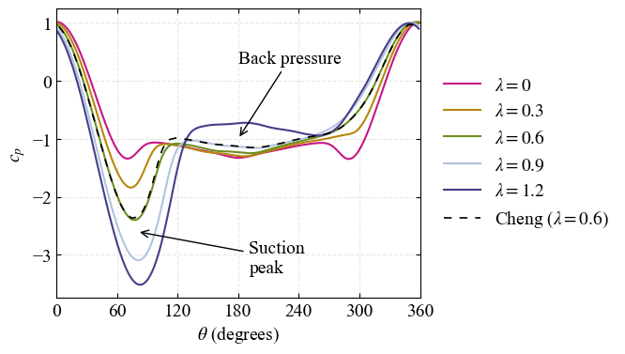
Figure 1: Coefficient of pressure distribution for a rotating cylinder at Re_{D} = 10,000. Present LES at velocity ratios ranging between λ = 0 and 1.2 compared with numerical data from Cheng et al. (2017) at Re_{D} = 5,000.

